Dates:
From To

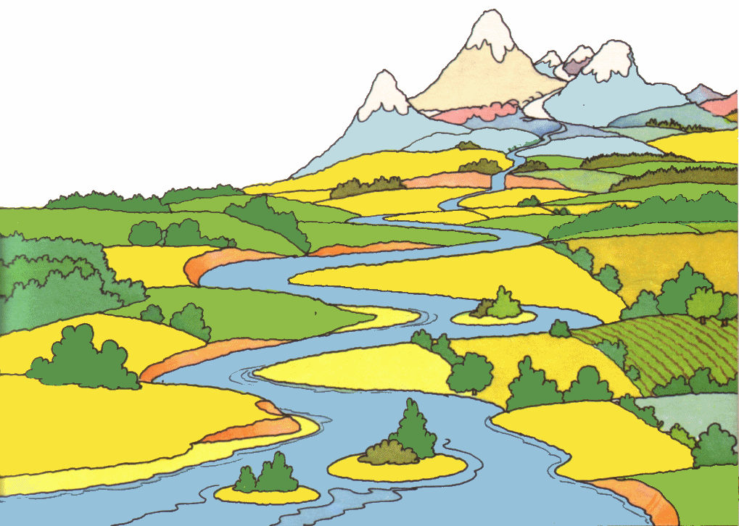
Erosion & Deposition

Vocabulary Bank:

Landform, topography, topographical map, contour interval, earth processes, destructive, constructive, weathering, erosion, deposition, floodplain, longshore current, jetty, breakwater, seawalls, sediment, landslide, river delta
Pages C3 to C57
Dates:
From To
Plate Tectonics
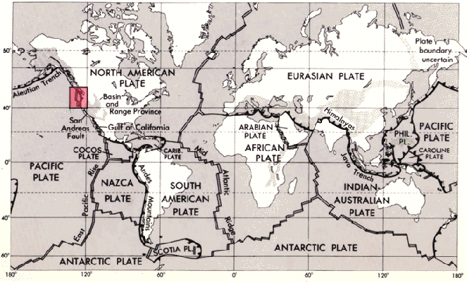

Pages D3 to D58
Vocabulary Bank:

Volcano, lava, crust, mantle, core, outer core, inner core, lithosphere, Paleontologists, geological time, continental drift, plates, plate tectonics, seismograph, seismogram, transform boundary, divergent boundary, convergent boundary, subduction, convection, continental drift, plate boundary, earthquake, tsunami, p wave, s wave, magnitude

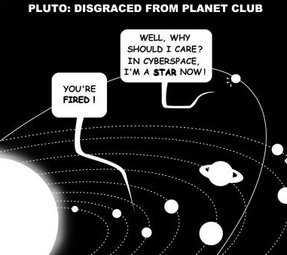
Dates:
From To
Exploring Space
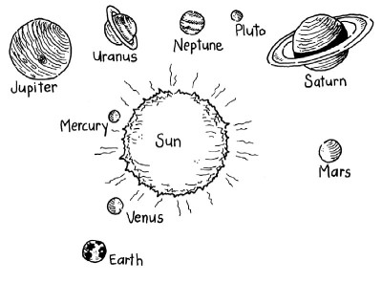

Vocabulary Bank:
Spacecraft, astronomer, planet, star, Solar System, scale, astronomical unit (AU), nuclear reaction, nuclear fusion, remote sensing, force, gravity, mass, weight, universe, orbit, ellipse,
Galaxy , satellite

Pages G3 to G6
Dates:
From To
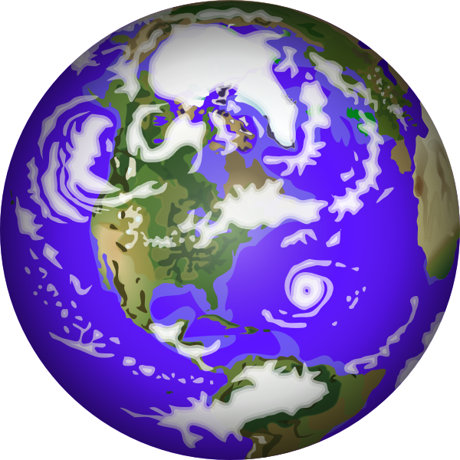
Earth in Space

Vocabulary Bank:

rotates, axis, rotation, revolve (revolution), orbit, revolution, phases, full moon, new moon, lunar cycle, solar, waxing, waning, solar, crescent, gibbous
Text Book Pages F3 – F65
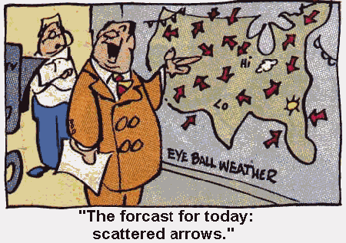
Dates:
From To
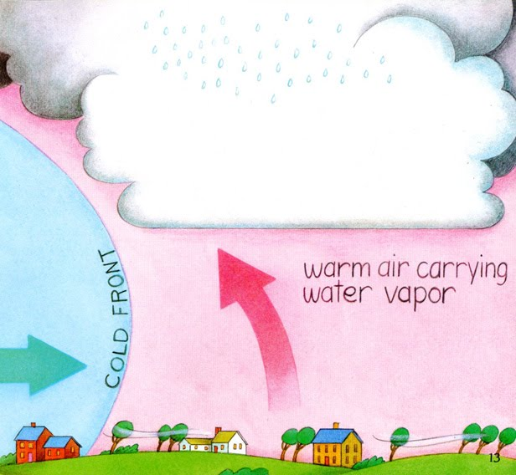
Weather & Atmosphere

Text Book Pages E3 – E98
Vocabulary Bank:

Meteorologists, precipitation, atmospheric scientists, weather, climate, Climatologists, Hydrologists, mean, median, mode, salinity, water vapor, humidity, clouds, melting, freezing, evaporation, condensation, groundwater, atmosphere, troposphere, wind, greenhouse effect, anemometer, wind vane, prevailing wind, weather forecast, cold front, warm front, cumulus, cumulonimbus, cirrus, stratus

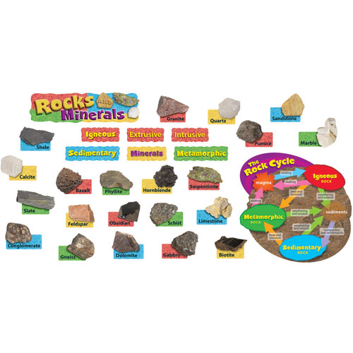
Dates:
From To
Rocks & Minerals

Text Book Pages B3 – B52
Vocabulary Bank:

Natural resources, properties, Geologists, sediments, sedimentary, magma, igneous, metamorphic, rock cycle, sediments, lava, law of superposition, archaeologist, mineralogist

